**Class Project-3**

1. This is an interactive plot where I have added number of flights for each year and number of flights by weekday, if we click on a year, we get the line graph where we can see the greatest number of flights are on which day of the week. For Example, if we click on

1999, we can see that it has maximum number of flights on Friday. Also, if we hover over it, we can see the count of the flights for Friday for 1999.

From the graph we can observe that

In 1998 more flights are on Tuesday

In 1999 more flights are on Friday

In 2015 more flights are on Wednesday

In 2016 more flights are on Friday

In 2020 more flights are on Tuesday

In 2021 more flights are on Sunday

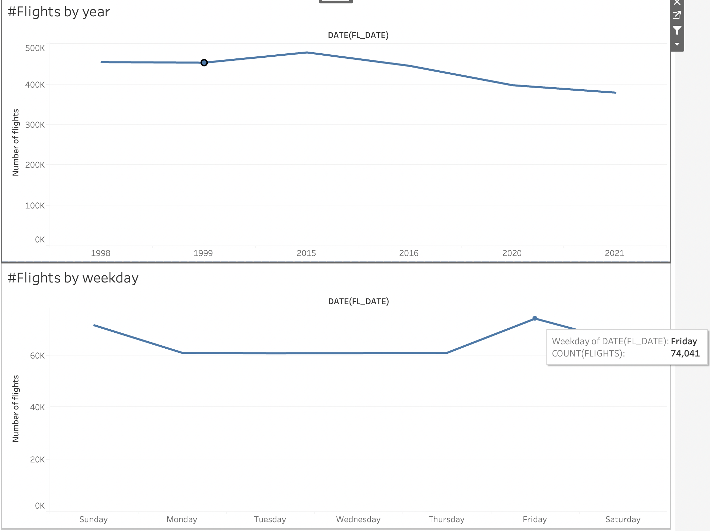

1. This is an interactive plot where I have created two plots in a dashboard. If we select in 1998, we get the taxi out time for top 10 airports and from the plot we can observe that,

In 1998 Taxi out time was highest for New York.

In 1999 Taxi out time was highest for New York.

In 2015 Taxi out time was highest for New York.

In 2016 Taxi out time was highest for New York.

In 2020 Taxi out time was highest for Charlotte.

In 2021 Taxi out time was highest for Charlotte.

From the trends we can infer that New York and Charlotte has highest taxi out times.

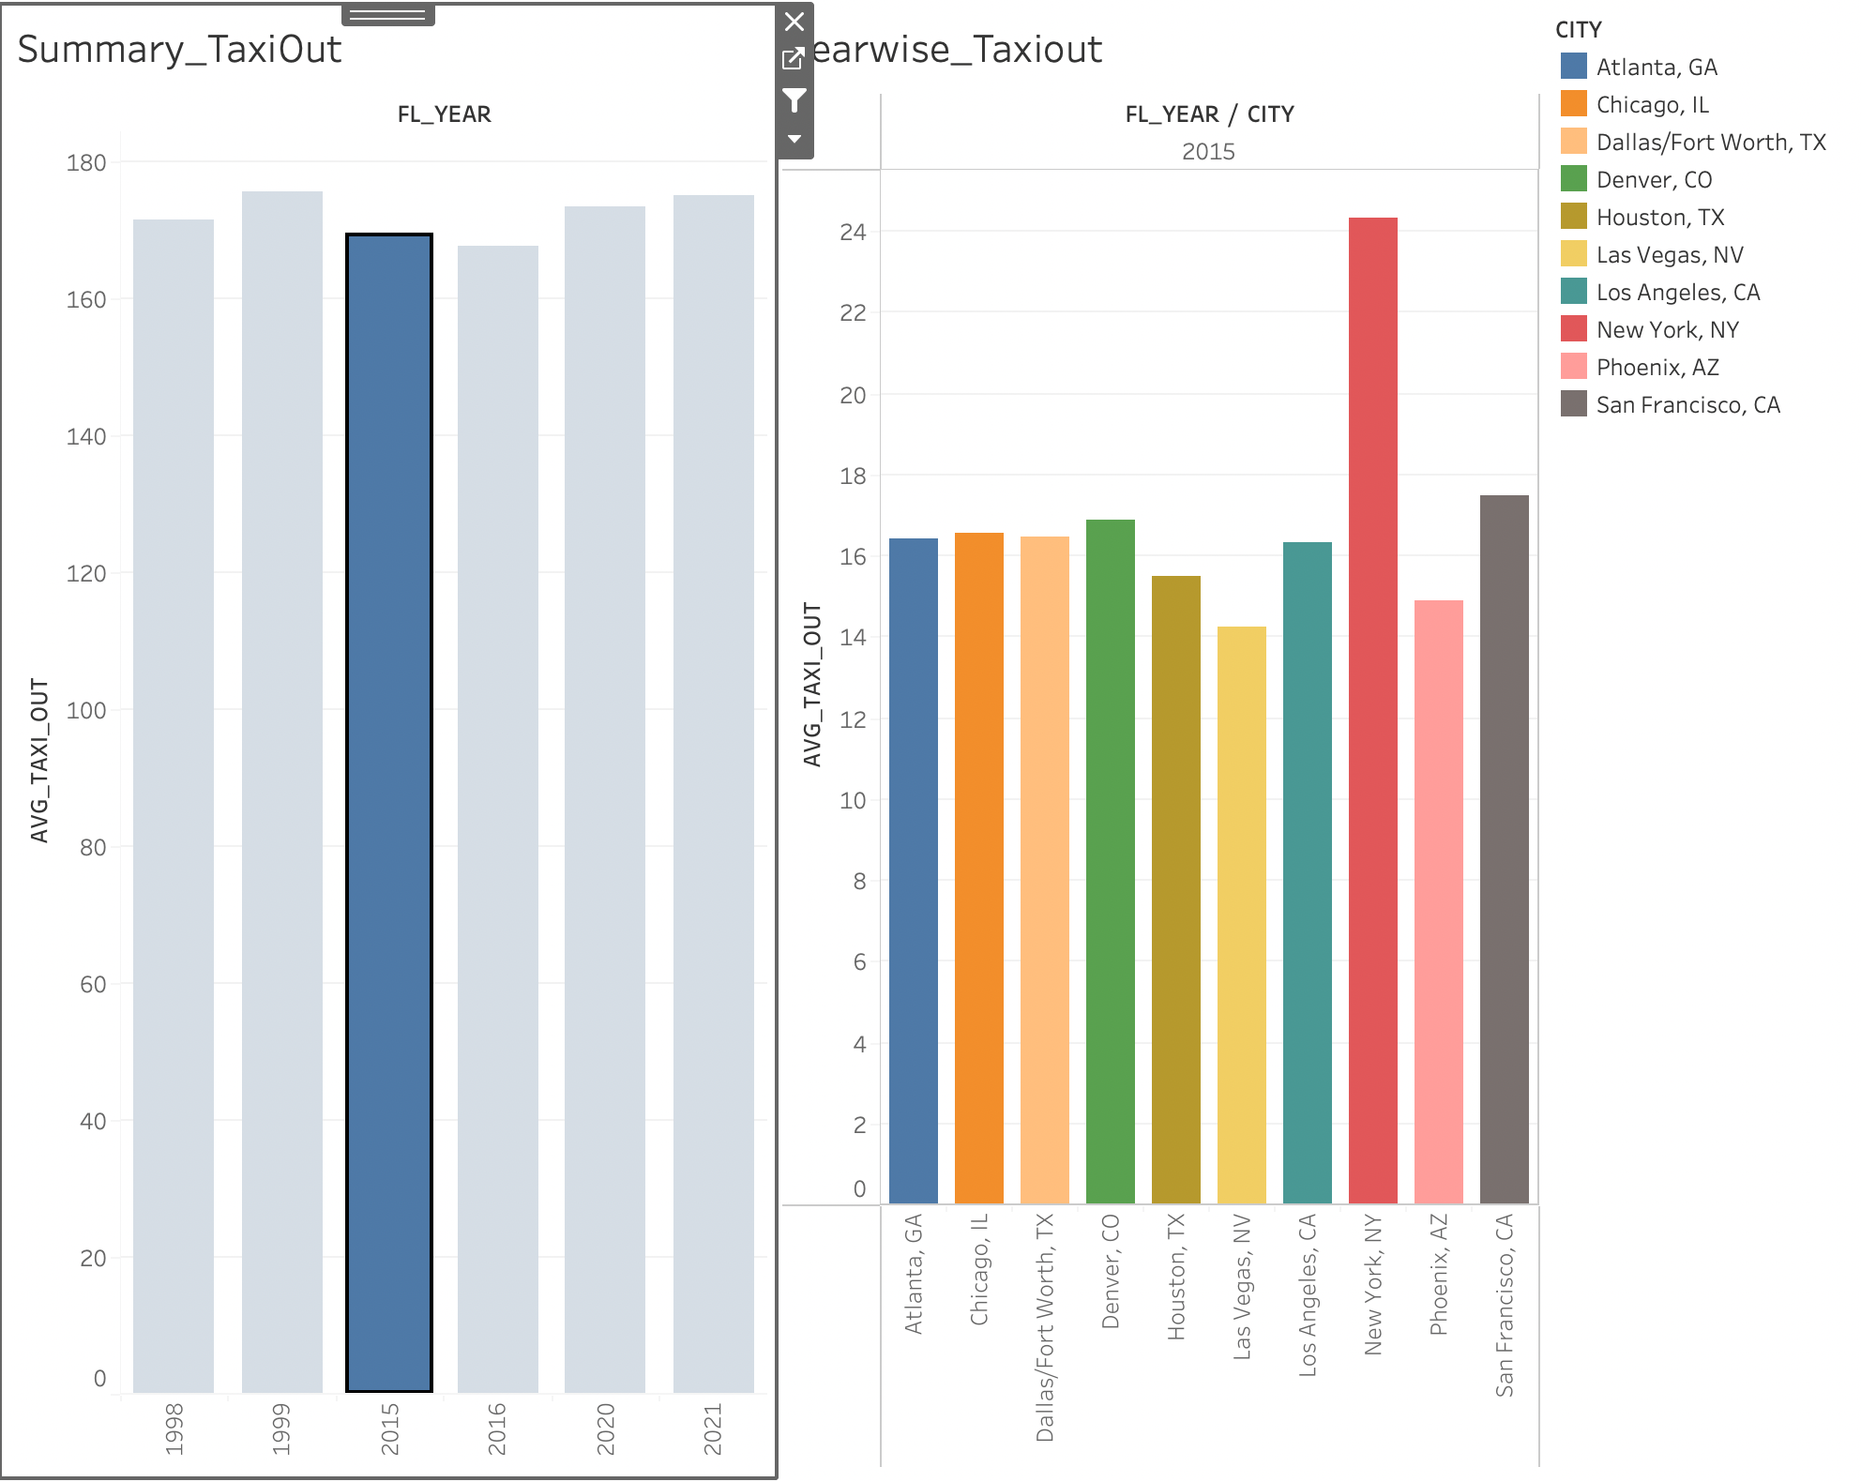

1. To find the carrier with the maximum number of flights for each year I have used bar graph to plot it. From the plot we can observe that,

In 1998 Carrier UA has maximum number of flights

In 1999 Carrier UA has maximum number of flights

In 2015 Carrier WN has maximum number of flights

In 2016 Carrier WN has maximum number of flights

In 2020 Carrier WN has maximum number of flights

In 2021 Carrier WN has maximum number of flights

Therefore, overall, we can see that

Carrier UA has maximum number of flights in 1998 and 1999 and

Carrier WN has maximum number of flights in 2015,2016,2020,2021

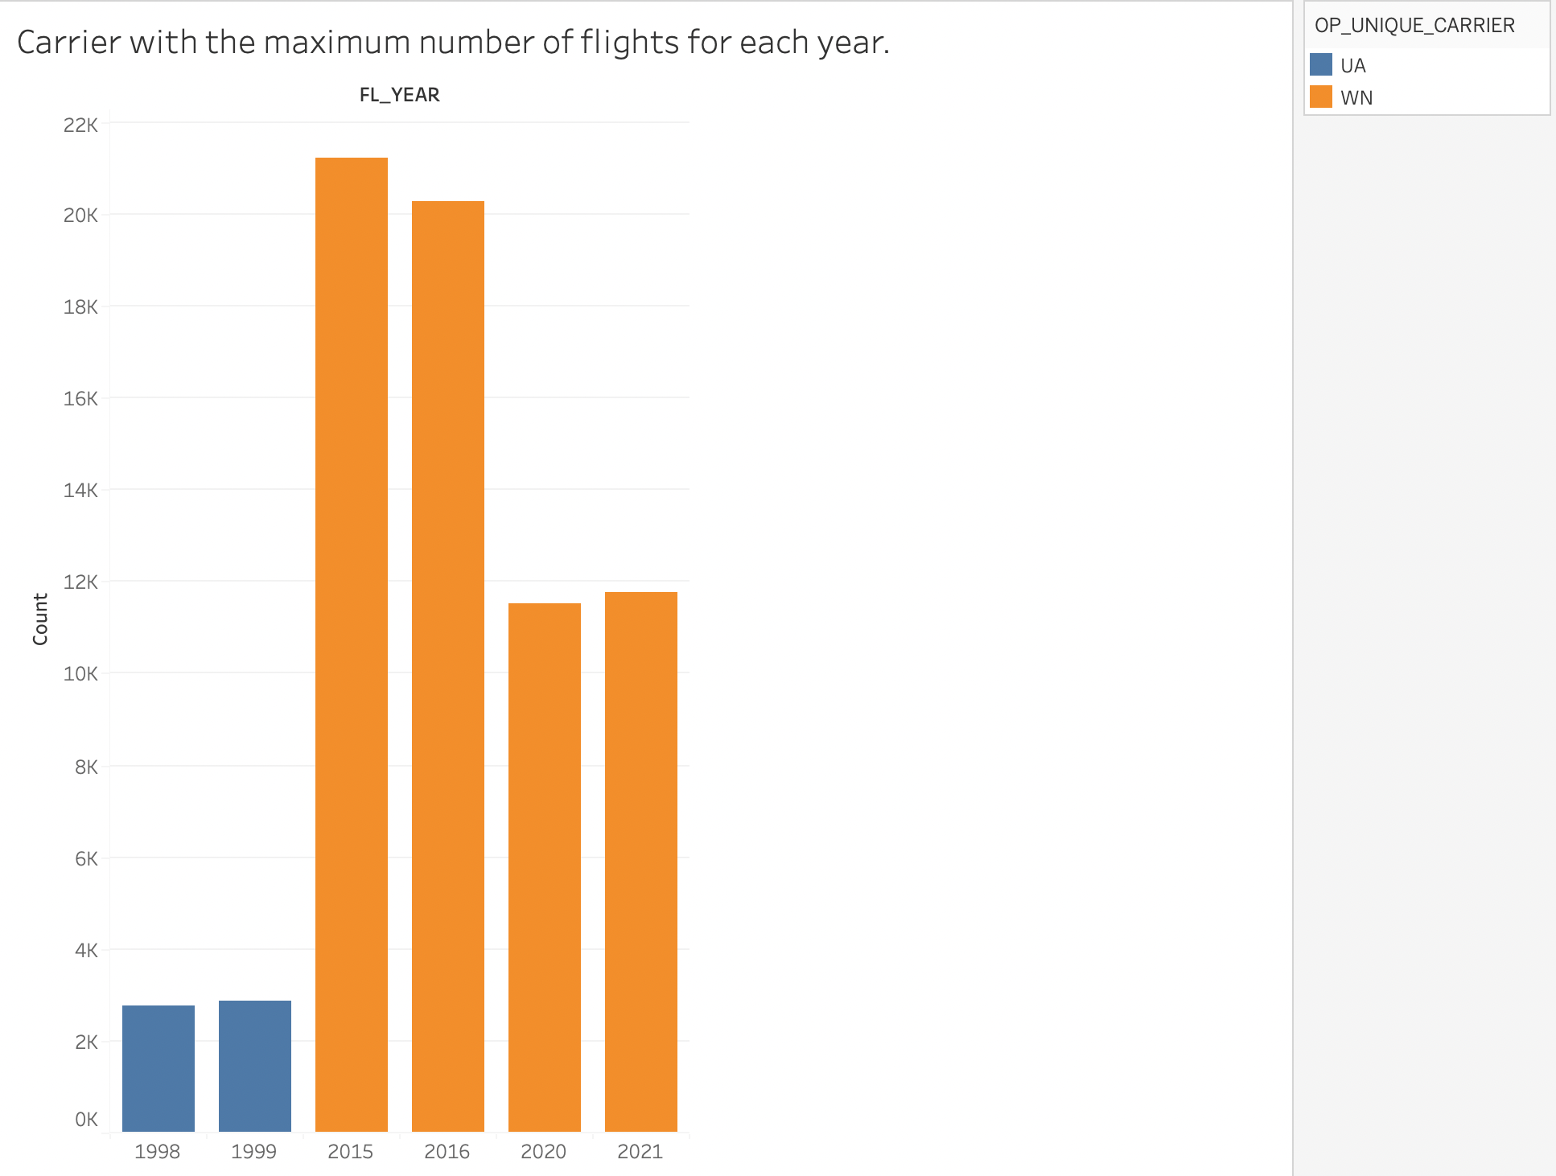

1. Calculating Maximum Airtime year wise. For plotting it I have used boxplot.

And from plot we can observe that ,Airtime is maximum in 2016 amongst all the years.

For 1998, and when we hover over it, we can observe that airtime was maximum for flights whose origin was Newark and whose destination was Honolulu with an airtime of 632.

For 1999, and when we hover over it, we can observe that airtime was maximum for flights whose origin was Newark and whose destination was Honolulu with an airtime of 630.

For 2015, and when we hover over it, we can observe that airtime was maximum for flights whose origin was New York and whose destination was Honolulu with an airtime of 690.

For 2016, and when we hover over it, we can observe that airtime was maximum for flights whose origin was New York and whose destination was Honolulu with an airtime of 698.

For 2020, and when we hover over it, we can observe that airtime was maximum for flights whose origin was Newark and whose destination was Honolulu with an airtime of 650.

For 202s, and when we hover over it ,we can observe that airtime was maximum for flights whose origin was Boston and whose destination was Honolulu with an airtime of 662.

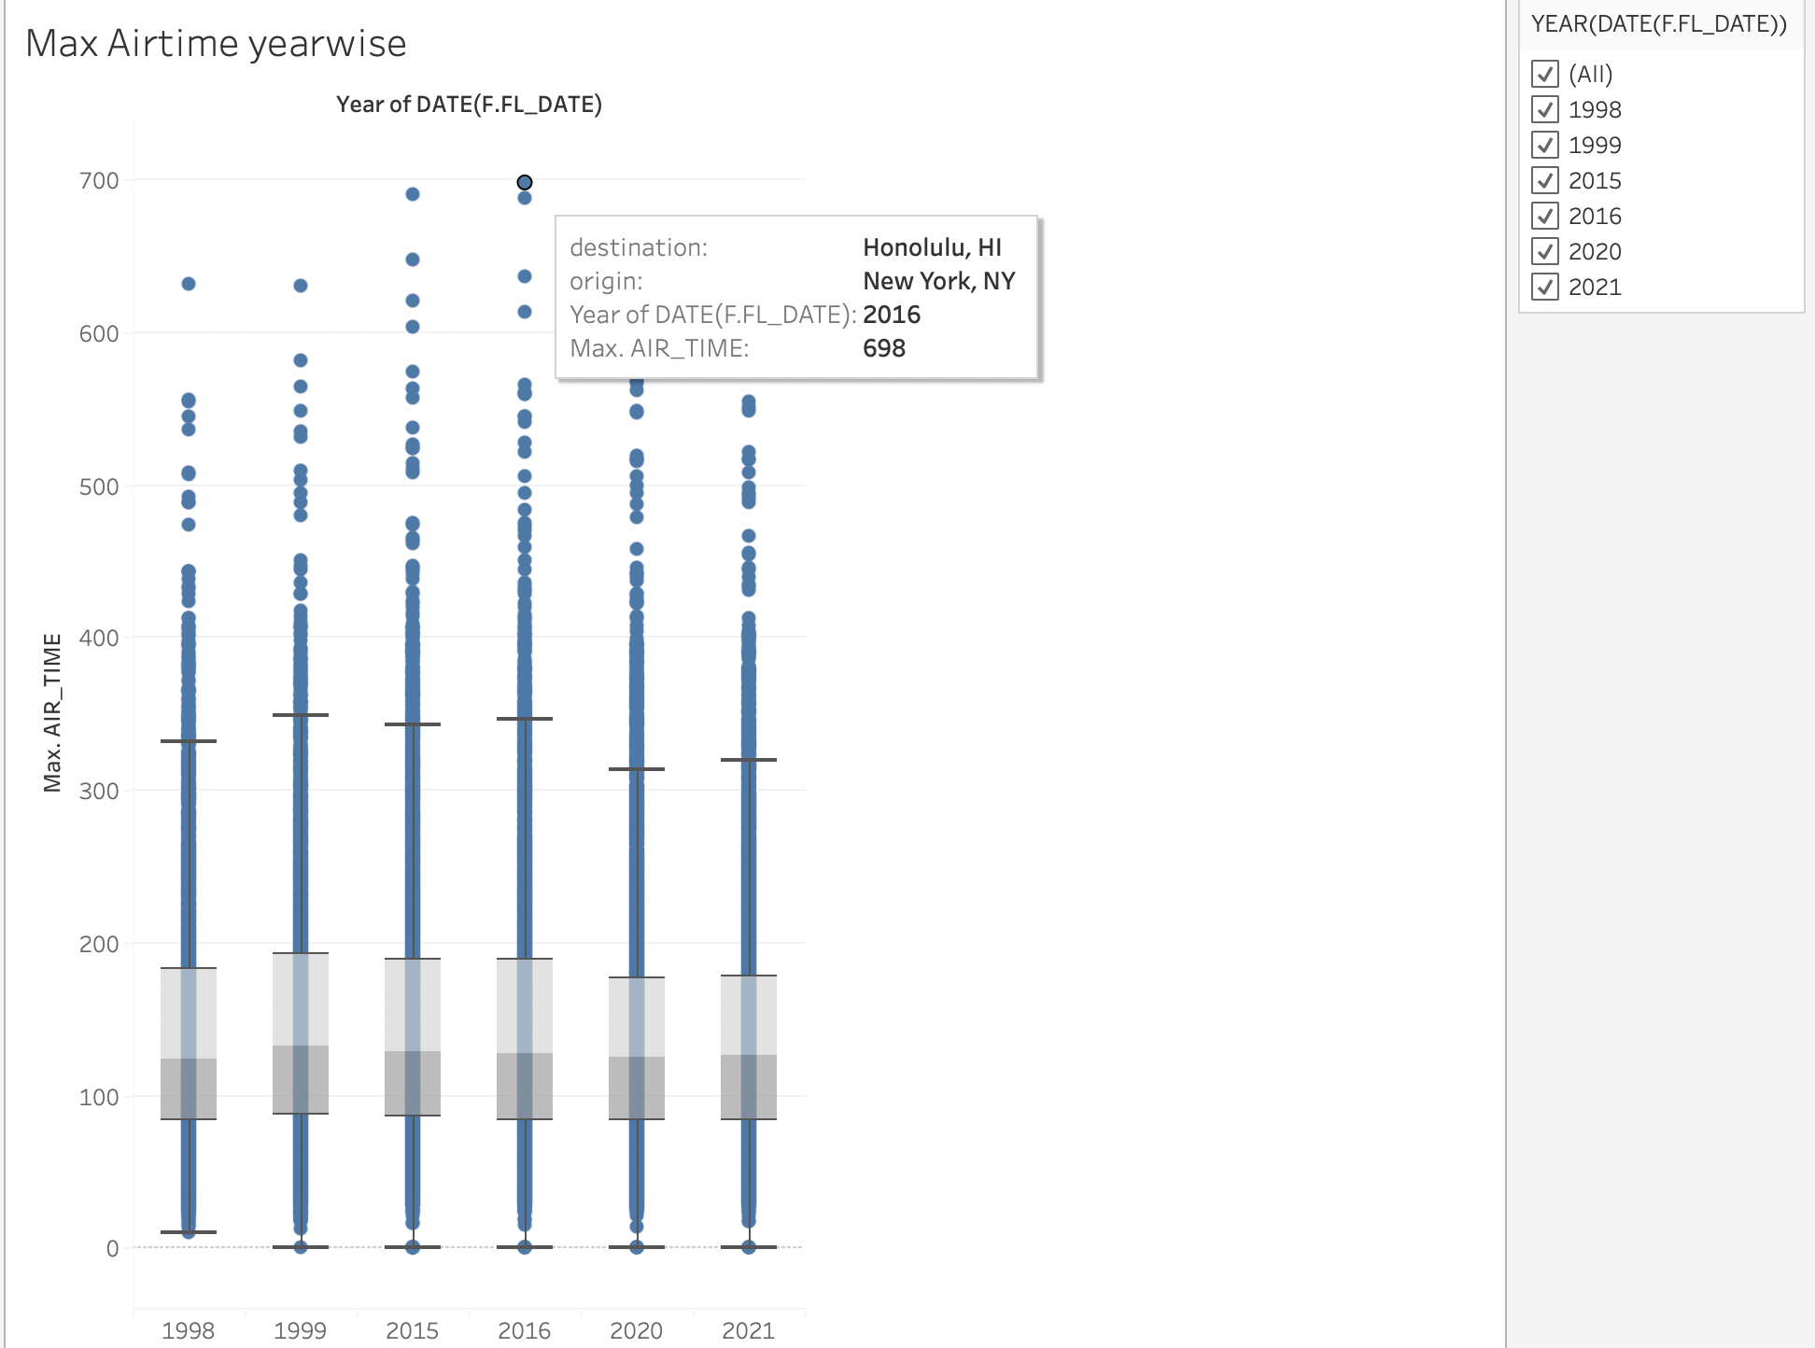

1. For plotting longest distance covered by the flights year wise I have used bar graph. This is an interactive plot.Where we can observe year wise longest distance for each carrier. When we hover over it, we can get the year, carrier name and distance travelled by the carrier year wise.

We can untick or tick the filter for year to modify asper year.

From the plot we can observe that,

In 1998 & 1999, the carrier "CO" has travelled the longest distance of 4962

In 2015 & 2016, the carrier "HA","DL" has travelled the longest distance of 4983

In 2020 & 2021, the carrier "HA" has travelled the longest distance of 5095.

The carriers such as G4, YV, QX,9E, OH, G7, ZW, C5, PT, EM are recently started and flying the least long distance among the other carriers.

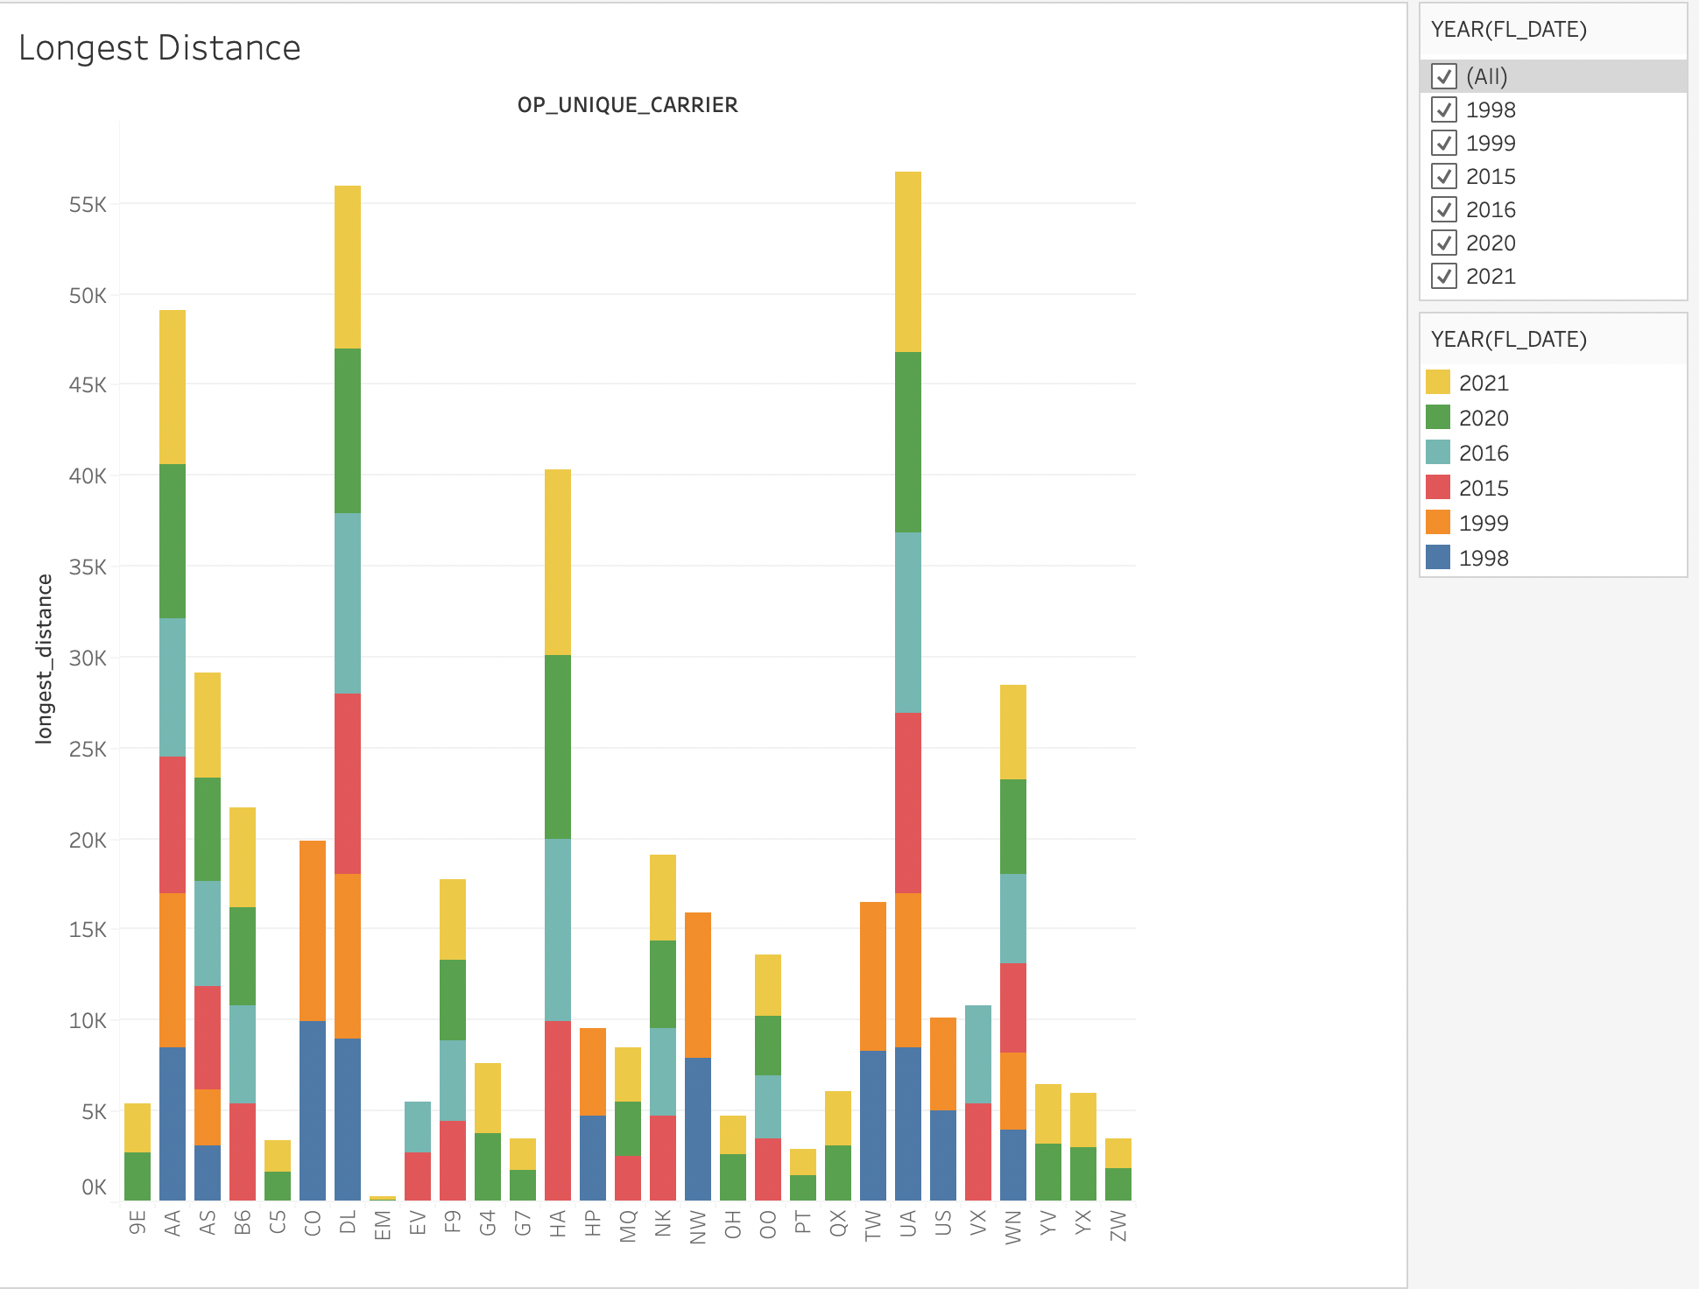

1. Busiest origin airport

The busiest origin airport which has larger number of flights is shown by using the box plot and table.

From the plot we can observe that, highest number flight count is recorded for the year 2015 and ATL airport

In 1998, most of flights have origin as ORD,ATL,DFW,LAX,STL

In 1999, most of flights have origin as ORD,ATL,DFW,LAX,PHX

In 2015, most of flights have origin as ATL,ORD,DFW,DEN,LAX

In 2016, most of flights have origin as ATL,ORD,DEN,DFW,LAX

In 2021, most of flights have origin as ATL,DFW,DEN,CLT,ORD

In 2020, most of flights have origin as ATL,DFW,DEN,ORD,CLT

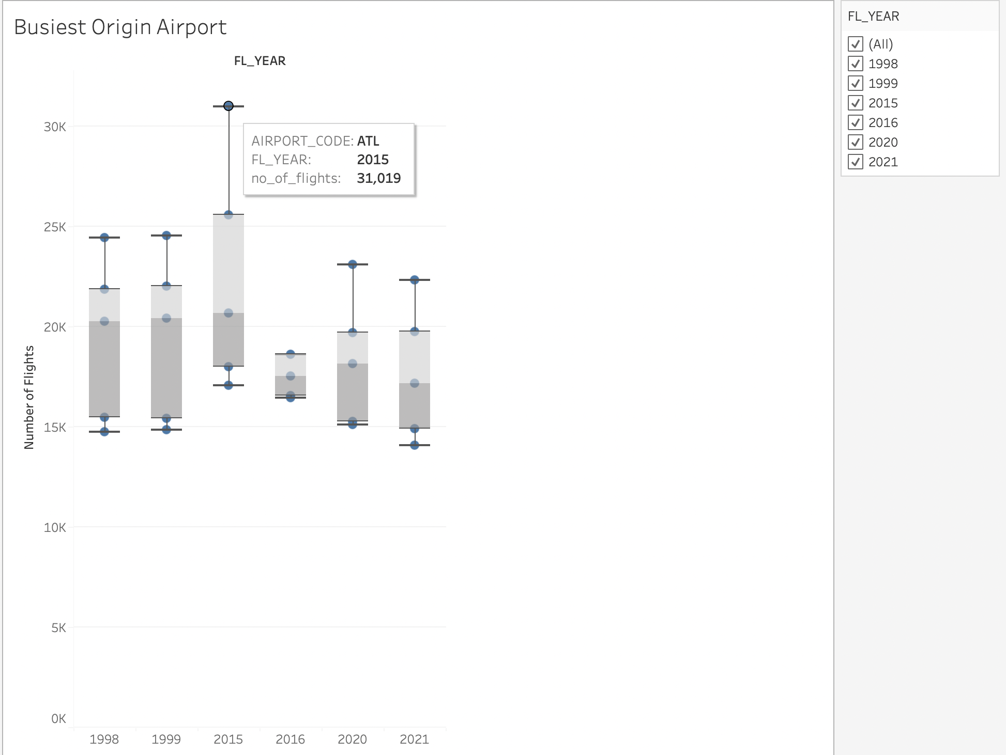

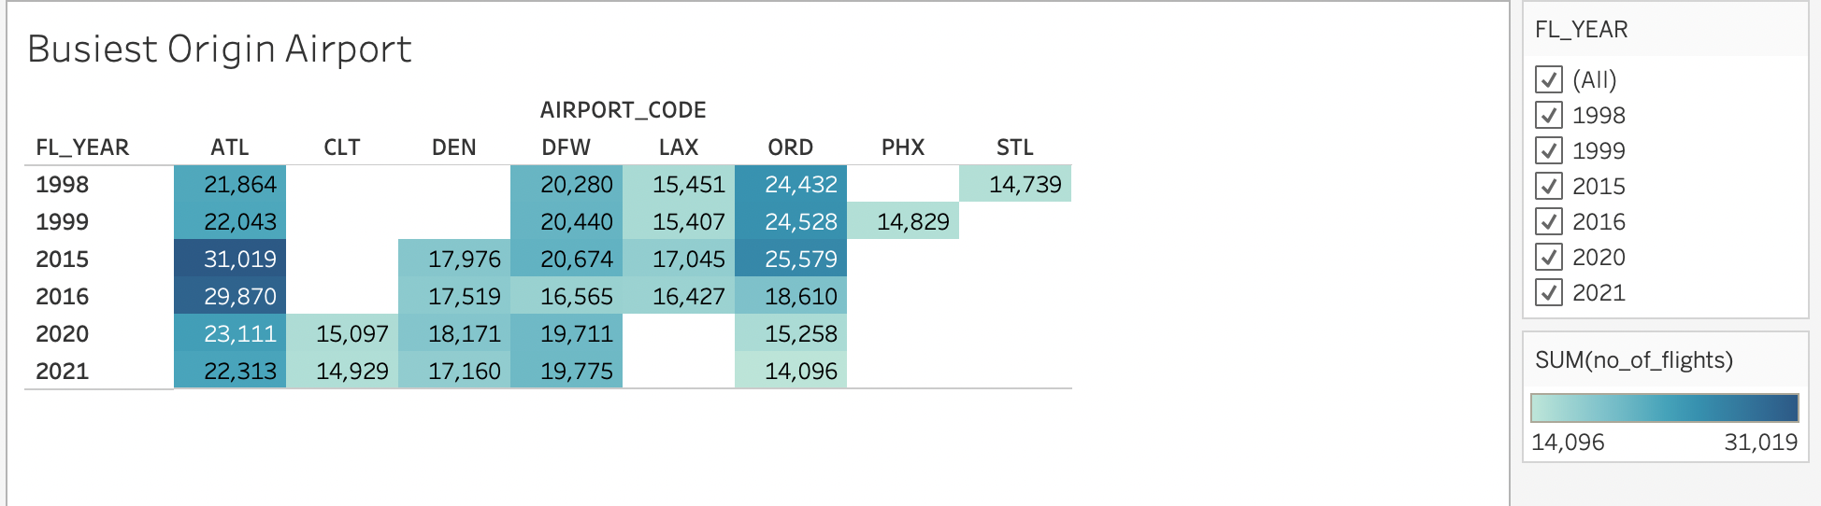

1. Average taxi out time for every origin airport in 2020.

To plot this, I have used bar graph.

From which we can observe that the Taxi out is maximum in Charlotte compared to all other origins in the year 2020.

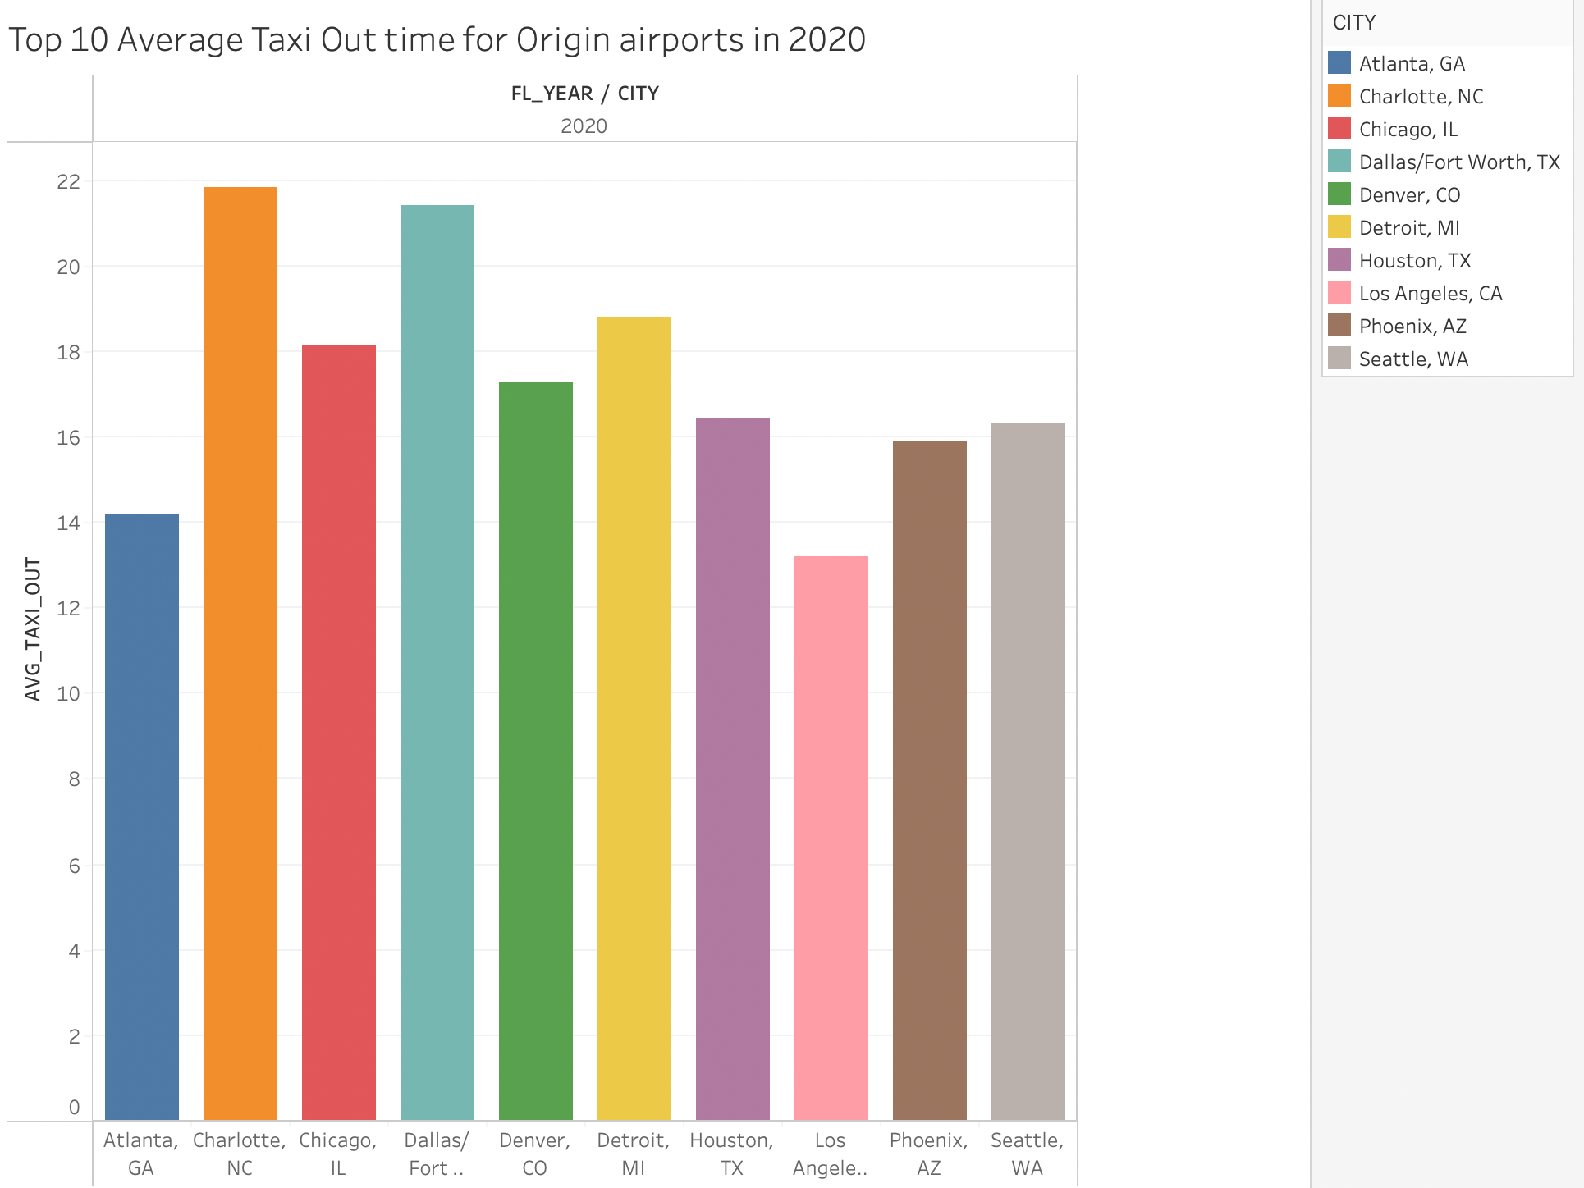

1. Busiest destination airports

The busiest destination airport which has larger number of flights is shown by using the box plot and table.

We can observe that highest number flight count is recorded for the year 2015 and ATL airport

In 1998, most of flights have destination as ORD,ATL,DFW,LAX,STL

In 1999, most of flights have destination as ORD,ATL,DFW,LAX,PHX

In 2015, most of flights have destination as ATL,ORD,DFW,DEN,LAX

In 2016, most of flights have destination as ATL,ORD,DEN,DFW,LAX

In 2021, most of flights have destination as ATL,DFW,DEN,CLT,ORD

In 2020, most of flights have destination as ATL,DFW,DEN,ORD,CLT

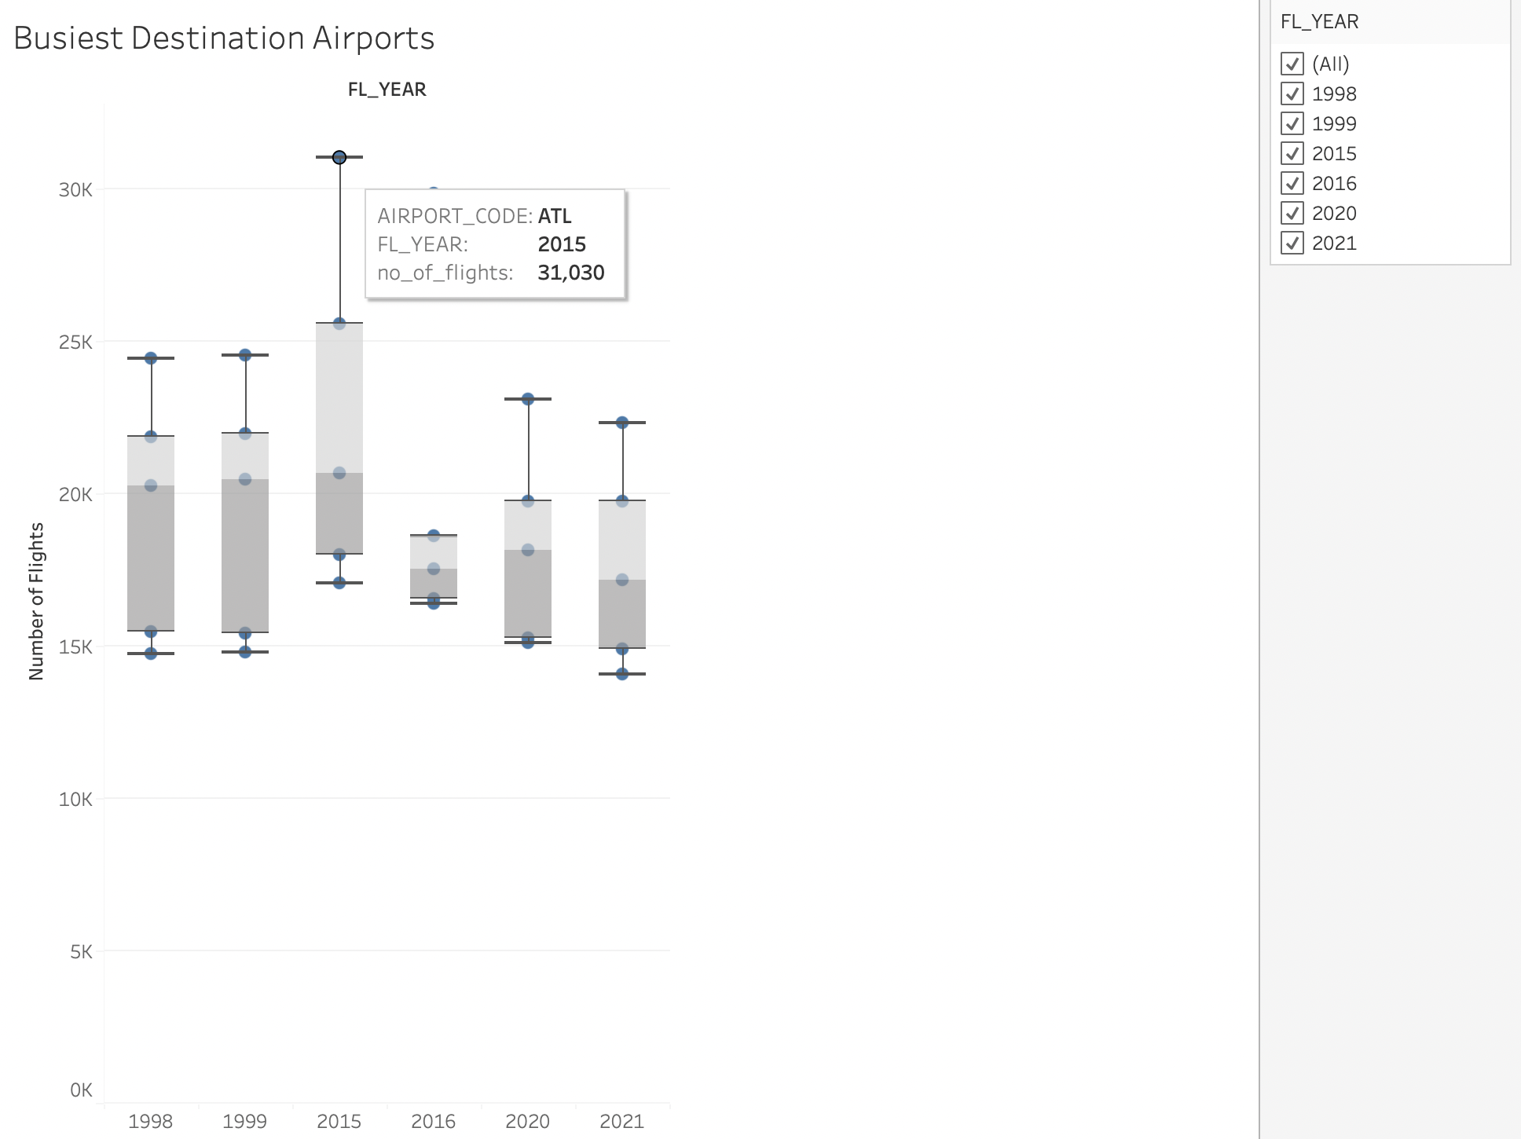

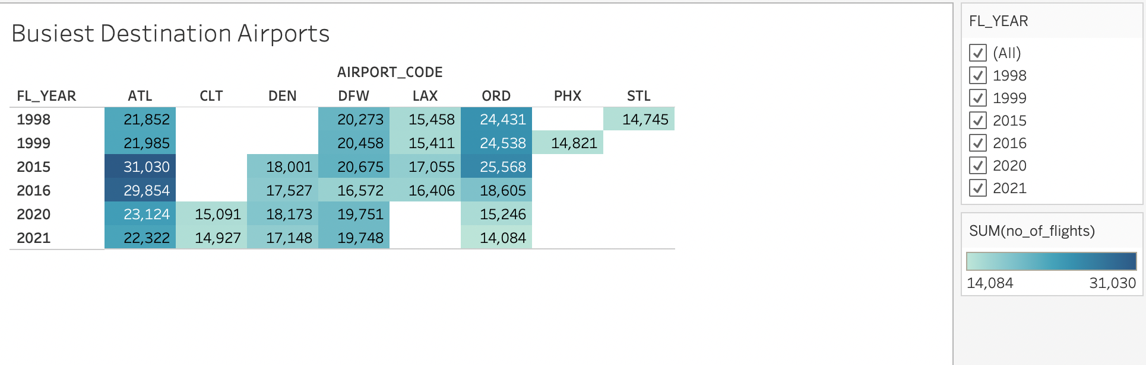

1. Average taxi in time for every destination airport in 2020.

To plot this, I have used pie chart.

From which we can observe that the Taxi in time is maximum in Dallas with an average of 12.70 min compared to all other destinations in the year 2020

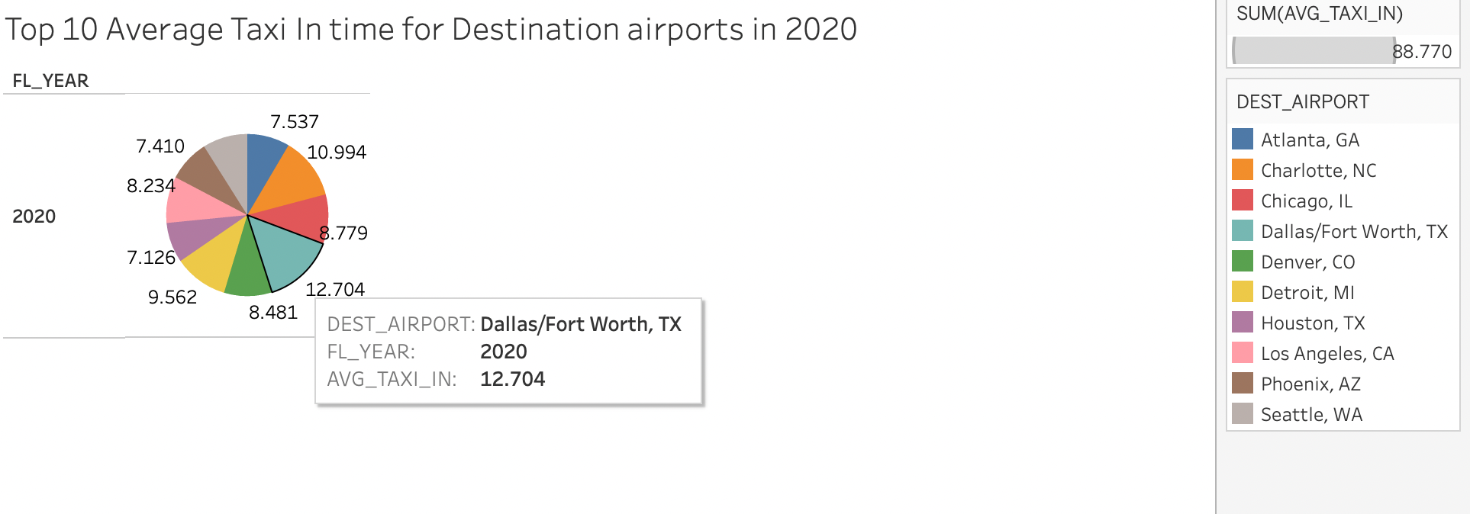

1. Flights count by day of week in Washington DC.

I have used tree map and a table to plot it.

From the plot we can observe that for Washington DC,

In 1998 more flights are on Tuesday

In 1999 more flights are on Friday

In 2015 more flights are on Wednesday

In 2016 more flights are on Friday

In 2020 more flights are on Tuesday

In 2021 more flights are on Sunday

